MODULE 2: Bone Basics & Fracture Mechanics

2.1 Structure & Function of Bone

In the late 1600’s, Leeuwenhoeck16, one of the first of the researchers to study bone structure and function published observations of osteons (building blocks of bone) at the microscopic level. Landmark findings include the concept that bone is formed and resorbed throughout life20, the finding that the surrounding muscles determine the form of bone6 and the statement that there is a relationship between function and structure of bone26.

This theme of related structure and function guides research in the next century. Important discoveries and theories are proposed laws by Wolff27 that summarize an interdependence between form and function of bone, and the proposal by Roux24 that the orientation of bone trabecula corresponds to the direction of tension/compression which is an example of how bone architecture follows engineering principles.

Bone is a living tissue composed of a protein matrix which is osteocollagenous and minerals (calcium salts). Twenty percent of the bone is water, while the matrix and salts contribute 35% and 45% respectively. Bone can be classified as cancellous (otherwise known as trabecular) or cortical (compact) which do not differ greatly biomechanically despite their differing density and porosity.

Bone as a Material

Bone can be examined as a material and the material properties of bone can be characterized by the load deformation relation. By applying a load to a tissue such as bone, then the change in length (deformation) can be measured.

Intrinsic material properties of bone can be expressed in two other measures:
Stress: force per unit area
Strain: change in length relative to original length

Stiffness of the bone is the relationship between stress and strain and this relationship can be plotted like a graph (see figure 2.1). Each region of the slope provides a reflection on the bone’s material properties:
Elastic/linear region: an area of low stiffness, (calculation of this relationship provides a number =elastic modulus). This is the region in which changes in the original length of the material will return to normal length. On figure 2.1 this is the region which is linear.
Plastic region: high stiffness region – where the material yields and damage accumulate here due to the rearrangement of internal structures. On Figure 2.1, this is the non-linear (curved) region of the graph.
Ultimate yield point - Following the plastic region where the material 'breaks'.
The area under the curve indicates the amount of energy absorbed upon application of force.

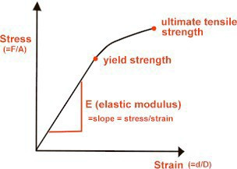
Figure 2.1 Stress-strain curve characteristics.

Bone as a Structure

Bone can also be characterized by its structure. Unlike the material properties of bone, structural properties are dependent on the geometry of the bone.

Size, shape, cross-sectional area, and trabecular orientation in the body (i.e., direction that it encounters compressive loads) determines the biomechanical properties.

The stress that a bone can withstand depends significantly on the size (cross-sectional area) of that bone and therefore those bones whose function is to withstand large stresses must have a large cross-sectional area right back to the connection between structure and function.

FACT: most asymptomatic bones can withstand forces between two and five times what they normally are subjected to in activities of daily living.

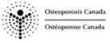

2.2 Mechanical Behaviour of Bone

You can certainly imagine that your daily activities result in all kinds of forces placed on the body - every change of position results in some type of force being transmitted through your bones and joints. Therefore, bones are subjected to compressive, tensile and shear stresses daily. Occasionally external forces are applied to our bones which are excessive; take for example being hit on the leg by a taxi while trying to cross the street. This could result in a bending load being applied to your tibia.
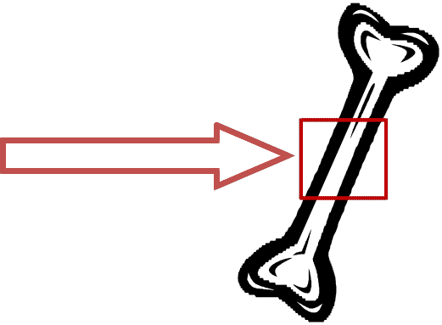
See figure below for what happens on each side of the bone.
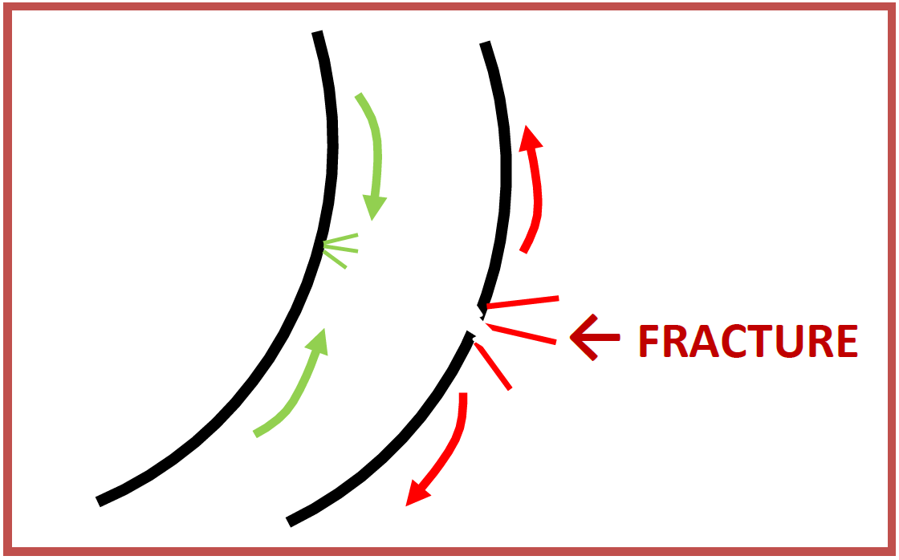

External force applied

Effects of Altered Geometry

As mentioned briefly above, the strength of bone is affected by both age and geometry. During the aging process, bone tissue is resorbed from the endosteal surface and the laid down on the periosteal surface which leads to thinner bones with a larger diameter. So while a thinner bone would be more likely to break, the increase in cross-sectional size can partly compensate for this.

Why is this?

First, the bending strength of a rod varies as the cube of the radius of the rod. Therefore, a change in radius by as little as 1mm can increase the strength by 33%. However, if bones were a solid rod, it would be very strong but too heavy to move. The compromise is hollow bones with a reasonable diameter.

Biomechanical Bone Proof:

If your bone was a solid rod 12mm in diameter, it would be just a strong as a hollow bone 14mm in diameter; however, it would weigh 1.5 times as much!

Fracture Pattern: Bending Force

We’ve now learned that when bending force is applied to a long bone, the failure point is more than likely to be the convex (tension) side. This results in tension failure to occur progressively across the bone creating a transverse fracture. There is a purpose for the bone to fracture it is the method in which the energy applied during the trauma is dissipated. Therefore, it is logical that if a high velocity force is applied to the bone, more energy needs to be dissipated and more cracks in the bone would be generated in the bone to dissipate this energy. Low velocity impacts usually result in a single transverse crack extending 1/3-1/2 of the circumference of the bone, often making unpredictable, oblique angles.

Fracture Pattern: Torsion

Of course, injuries to bones don't always occur by bending but by twisting forces. For example, when the foot is fixed and the body falls or rotates forcefully (a fall while skiing).

The resulting torsional load on the tibia in this case produces a constant moment throughout the long bone since the moment applied to the fixed segment (in the ski boot)
is the exact magnitude but in the opposite direction as the moment closer to the knee joint.

Generally, the pattern of the torsional fracture is thus a spiral which is perpendicular to the maximum tensile strength applied. Similar to the bending fracture pattern, loads that are rapidly applied produce more fracture lines, a double spiral pattern.

Fracture Pattern: Compression

Compressive loading involves the application of equal and opposite loads into the structure, resulting in compressive stress and strain within the structure and a resulting shortening and widening of that structure. If the load is applied on the plane perpendicular to the object surface, this results in maximal compressive stress. As the vertebrae are subjected to high compressive loads under normal circumstances, it is expected that these bones in particular would be susceptible to undergoing compressive fractures. In other joints, compression fractures can be elicited with abnormally high muscular contraction forces around the joint. Although this doesn’t typically apply to a vertebral segment, consider the effect of repeated, high muscular work on one aspect of the vertebrae and that contribution to developing vertebral fractures.23

Typical patterns of vertebral fractures include crush and wedge fractures. Crush fractures occur in the condition in which compressive forces are distributed nearly equally throughout the entire vertebral body, thus causing an equal loss of height throughout the entire vertebral body. Wedge fractures, on the other hand, are generally a result of accentuated compressive forces on one aspect (most typically anterior) of the vertebral body, resulting
in a more wedge-shaped vertebra.

See Figure 2.2 (adapted from STAND TALL by Morris Notelovitz, M.D. Triad Publishing, Gainesville, Florida)
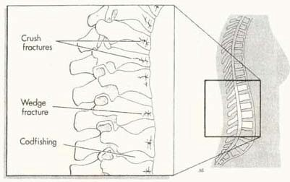
FIGURE 2.2 – examples of vertebral fracture patterns

Effect of Aging on Cortical & Trabecular Bones

Cortical Bone:
The effect of aging results in cortical bones diminishing ability to resist fracture. Elastic properties decrease somewhat but it is the toughness and strength of the bony material which diminishes even more so. Research has revealed that the stiffness of femoral cortical bone reduces 1-2% per decade after 35 years old, while maximum stress (strength) decreases 2-5% per decade2,28. Most significantly, the toughness of cortical bone (the energy to fracture) decreases 10% per decade which means that lower energy events impacting the bone in the older persons would result in a fracture which would not occur similarly in a younger person. In addition, cortical bone is porous to begin with and this porosity increases significantly with age.17

Take-home Point
Increased porosity is a major contributor to the loss of strength, stiffness & toughness as we age.

Trabecular Bone:
Trabecular, or cancellous, bone strength is dependent largely upon the density of its trabeculae – according to some research, this accounts for approximately 60% of the variance in strength in sites around the body.9 Since trabeculae are arranged in different patterns within bone, if forces are directed through the bone trabeculae along its principal orientation, strength variance rises to 90%.

Take-home Point
Trabecular bone is strongest in its densest region with the forces going along the path in which most of the trabeculae are arranged.

With aging in men and women, the apparent density of trabecular bone decreases significantly and thus, the strength of the bone is proportionately decreased.18, 21

It’s reported that the compressive strength of vertebral trabecular bone decreases between the ages of 25-75 year by 70% and proximal femoral trabecular bone loses 50% of its strength in the same time span.18 Accounting for this loss of strength is a reduction in the thickness and number of individual trabeculae, resulting in a loss of density.8, 9

Whole Bone Changes with Age:
With age, the proximal femur undergoes significant loss of structural integrity, thus leaving it vulnerable to damage under low force conditions. Research comparing younger and older femoral specimens revealed that in the older specimens there was a reduction of strength by 50%, stiffness by 30% and overall toughness by 70%.4

Similarly, vertebrae also undergo age-related changes in strength which are particularly related to the density and strength of the vertebral trabecular bone. Between the ages of 30 and 90, compressive strength of the vertebrae decreases by 80%.⁵

2.3 Fractures in Osteoporosis

Fractures are the most serious clinical signs of osteoporosis as well as the clinical sequelae which have the most impact on a patient’s function, psychological well-being and
life. As mentioned earlier 80% of hip fractures are osteoporosis-related. Hip fractures result in death in up to 20% of cases, and disability in 50% of those who survive.

An osteoporotic fracture is often referred to as a “fragility” fracture or “low-trauma” fracture. In general, both of these are referring to a fracture resulting from a fall from standing height or equivalent degree of trauma. This includes: slipping on ice, tripping and falling, lifting something, coughing or sneezing. Often the term fragility fracture is interpreted to infer that the bones are particularly thin already, but a fracture resulting from a standing height fall can still cause a fracture in those who are just starting to lose bone density (osteopenic), so there seems to be a movement towards using the terminology
‘low-trauma’ fracture instead.

Usual sites of osteoporotic fractures include: ribs, wrist, spine, hip, and humerus. The reported lifetime fragility fracture risk is 1:2 for women; 1:8 for men.

Focus: Hip & Vertebral Fractures

It’s reported that over 90% of hip fractures in the elderly are as a result of a fall but interestingly only 5% of all falls actually result in a hip fracture.11 This suggests that it is not just the fall which causes a hip fracture and that there must be a fall characteristic, like point of contact or leg orientation which is the more important determinant of a fracture.25
Researchers have demonstrated that those people who fall to the side (onto the greater trochanter, for example) are 6-20 times more likely to sustain a fracture compared to other fallers.10,13 Other research using computer modeling has concluded that falling on the hip laterally with the leg internally rotated results in a high possibility of fracture as the femoral neck is weakest to a postero-lateral blow.14

While hip fractures are clearly most common as a result of falls, vertebral fractures are not as likely to arise from a fall, in fact only 1/3 result from falling.3 Vertebral fractures can arise from accidents or lifting heavy objects but nearly 60% are spontaneous and not related to a single incident or event. Thus vertebral fractures may occur incrementally and not catastrophically.
Osteoporotic fractures are nearly always end-plate fractures and thus results in a crush of the vertebral body (centrally or uniformly) or an anterior wedging of the vertebral body. The most clinically obvious result of vertebral fractures is a notable thoracic kyphosis or loss of height.

Point to Ponder:

Nearly all fractures cause deformities but not all deformities are due to fracturing… so the presence of kyphosis or loss of height alone may not be indicative of vertebral osteoporotic fractures.

Interestingly, hip and vertebral fractures are related. Prevalent vertebral fractures significantly increase the risk of future hip fracture. Several studies, have demonstrated a 2-3 fold increase over a 10 year period in the relative risk of hip fracture for those osteoporosis patients with a prevalent vertebral fracture versus those with no previous vertebral fracture.1,12,15,19

Point to Ponder:

Vertebral fractures are considered an early consequence of the progressive deterioration of bone health while a hip fracture is the outcome of advanced stage (severe) osteoporosis

2.4 Anatomy Review
2.4.1 SPINE
Bony Components:

The basic structure of each spinal segment is composed of two portions: the vertebral body
and the vertebral arch. (see Figure 1)

The vertebral body sits ANTERIORLY in the body and are the major weight bearing component of the spine, increasing in size from cervical to lumbar. Between each adjacent vertebral body are fibrocartilaginous intervertebral discs. Spinal curvatures are influenced by the shape of both discs and vertebral bodies. Generally, in the thoracic spine, where osteoporotic vertebral fractures typically occur, the vertebral body tends to be wedged anteriorly, or having less height in the anterior portion relative to the posterior portion. The shape of the vertebral body as well as the disc contributes to the natural primary curvature (kyphosis) which exists in the thoracic region (see Figure 2). This characteristic is more prevalent in the mid-thoracic region.7

The vertebral arch is comprised of two bony struts and three processes which make up the lateral and posterior aspects of the vertebral column. Directly connected to the vertebral body are two bony pillars on either side, called pedicles. (see Figure 1) Extending posteriorly and medially from each pedicle are two flat sheets of bone called the laminae. The two laminae meet in the midline posteriorly. Extending laterally and slightly posteriorly at the junction of the pedicle and lamina on either side is a transverse process.

The transverse processes provide important bony attachment points for muscles and ligaments and in particular in the thoracic region, for articulation with the ribs. Extending posteriorly and inferiorly, from the junction of the two laminae, is the spinous process. Similar to the transverse processes, this provides an important articulation site for muscles and ligaments.

The final bony prominences extending near the juncture of the pedicle and laminae are the articular facets, sometimes referred to collectively as the zygopophyseal joints (or z- joints). There are two processes on each side – one superior and one inferior. Each superior facet articulates with the inferior facet of the vertebrae above it thus creating that
z-joint and is the main component which dictates the movement for that spinal segment.

The superior and inferior articulating process in the thoracic region face relatively posteriorly and anteriorly, respectively.

Therefore, the movements predominantly allowed throughout the thoracic movement are rotation and side bending with minimal flexion and extension between each segment. Given that there are 12 segments, the total flexion or extension across the thoracic region could between 24 and 36 degrees.

Ligamentous Components:

The vertebral bodies and components of the vertebral arches are reinforced and connected to segments above and below by many ligamentous reinforcements. Each spinous process has two main ligaments, one set of ligaments that run in-between each subsequent spinous process – the interspinous ligament and another ligament that runs nearly the length of the column, joining tip to tip – the supraspinous ligament. (see Figure 3)

From the skull to C7, the supraspinous ligament spreads out in the midsagittal plane to become a distinct sheet-like ligament called the ligamentum nuchae. The purpose of these ligaments are to limit the amount of flexion and potentially to assist a return to neutral posture (a type of ligamentous rebound).

Ligaments between each transverse process – the intertransverse ligaments – help to limit side flexion and excessive rotation. The final ligament attaching to the vertebral arch is the ligamenta flava, a highly elastic ligament which attaches lamina to lamina. The main function of this ligament is to again resist excessive flexion and assist in the return to an anatomical position in extension. (see Figure 3).

Finally, there are two broad bands of continuous ligaments which span the length of the vertebral column, connecting vertebral bodies and intervertebral discs. One is located anteriorly – the anterior longitudinal ligament (ALL) and one posteriorly – the posterior longitudinal ligament (PLL). Each ligament, again, resists excessive movement – the ALL resisting extension and the PLL resisting flexion. (see Figure 4)

Intervertebral Disc:

Besides the z-joints, a movement segment for the vertebral column is the symphysis between the vertebral bodies, otherwise known as the intervertebral disc. The disc is composed of two parts – an outer collagenous ring surrounding a central gelatinous portion. (see Figure 5) The annulus fibrosus is composed of many layers of fibrocartilaginous lamellae which have the main function of limiting rotation between vertebrae. The nucleus pulposus, the jelly-like centre of the disc serves to help resist compressive forces placed through the vertebrae.

Important Fact: Posture Matters…

Reclining postures reduces intradiscal pressure 50-80%, while sitting increases the pressure by 40% and forward flexion and rotation increases it by 200%!22

Muscular Components:

Muscles acting on the spine can be divided into two main parts: an appendicular group and an intrinsic group. The appendicular group is composed of those muscles which attach to the upper limb and back and therefore act indirectly on the back. The group includes the rhomboids (major and minor), trapezius and latissimus dorsi.
The location of these muscles can be reviewed on Figure 6.

The intrinsic group of back muscles are those that originate and insert within the torso. They are deep to the appendicular group and can further be subdivided into two groups: the erector spinae group and the transversospinalis group deep to the erector spinae muscles.

The erector spinae muscles are three long bands from most medial to lateral: the spinalis, longissimus and iliocostalis muscles. This group broadly arises from the sacrum, iliac crest, and spinous processes of the lower thoracic and lumbar vertebrae. (Figure 7)

The most medially located band is the spinalis which connects spinous processes of adjacent vertebrae and are most plentiful in the thoracic region. The middle band, the longissimus is the largest portion, extending the entire spine and tends to be positioned over the transverse processes. The most lateral column is the ilicostalis and spreads out from the iliac crest to the ribs up to the lower cervical transverse processes. The function of this group is to side flex the spine when unilaterally activated and is the primary back extensor when contracted bilaterally. It also can help control spine flexion through controlled contractions.

The transversospinalis group gains its name from its muscle attachments, running up and medially from transverse process to spinous process.(Figure 7)
It is comprised of three major subgroups: the semispinalis, multifidus, and rotatares. The semispinalis is the most superficial of the group, starting in the lower thoracic region ending at the skull. Generally this muscle spans 4-6 vertebrae from origin to insertion. Deep to the semispinalis is the multifidus which runs the length of the entire column but is
most developed in the lumbar region. Generally this muscle spans 2-4 vertebrae from origin to insertion. The deepest group is the rotatores muscles. Best developed in the thoracic region (which makes sense as this is where most rotation occurs!), they are present in all parts of the spine. These fibres are generally very short and pass only 1-2 segments.

The function of this muscle group is similar to the erector spinae group in that bilateral contraction results in back extension and unilateral contraction results in side flexion. This group has more control of rotary action as well, given its angulated deep attachment and smaller segmental spanning when unilaterally contracted.

VERTEBRAL ANATOMY FIGURES

FIGURE 1
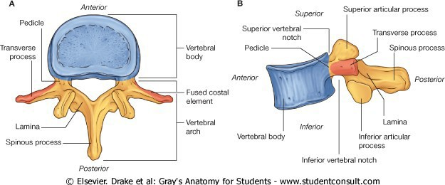

FIGURE 2 FIGURE 3
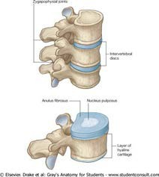
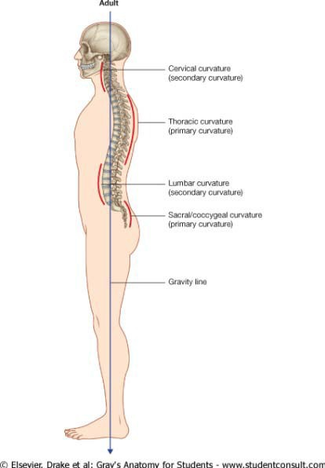

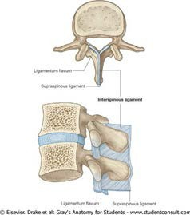
FIGURE 4 FIGURE 5

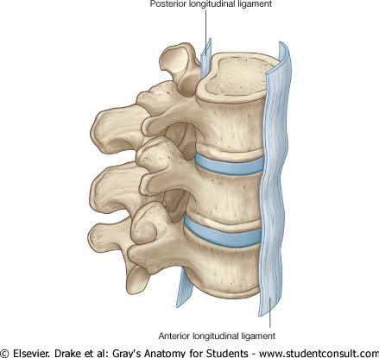

FIGURE 6 FIGURE 7
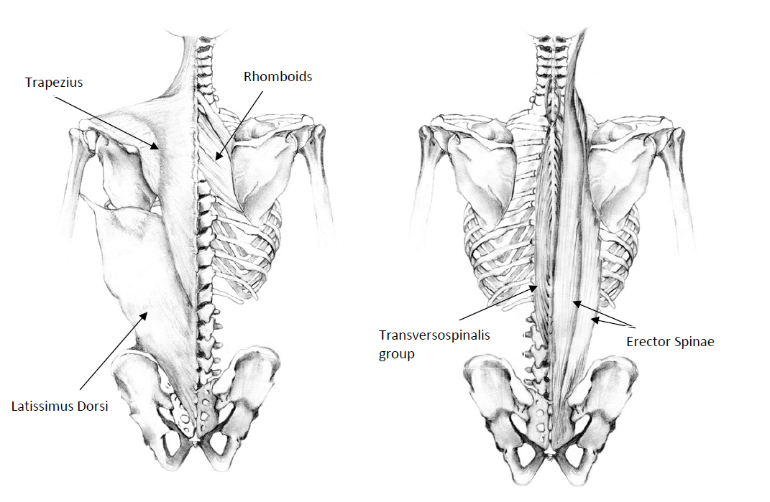

Illustration: A. Zariwny

2.4.2 HIP

Bony Components:
The hip joint is comprised of two portions: the head of the femur and the pelvic acetabulum. The spherical head of the femur features a fovea which is non-articular and is the attachment point for the ligament of the head of the femur. This ligament forms a protective sheath for a small branch of the obturator artery which supplies the femoral head. The acetabulum nearly entirely surrounds the head of the femur, thus making this joint highly stable. Around the rim of the acetabulum there is a fibrocartilaginous collar, the acetabular labrum which spans a deficiency of the labrum (acetabular notch) as the transverse acetabular ligament.

Extending laterally and inferiorly from the head of the femur to join the shaft of the femur at an angle of approximately 125 degrees is the neck of the femur. It is this orientation of the neck to the shaft which allows for great range of motion in the hip joint.

Ligamentous Components:
The hip, like all synovial joints, is surrounded by a fibrous capsule but is unique in that this capsule contains three thickenings which are interpreted as the ligaments of the hip. (see Figure 1) The three ligaments together all spiral around the femoral neck and head from posterior to anterior, such that they all become taut in extension and assist in the passive support of the joint during standing.

Most anteriorly is the iliofemoral ligament, which is shaped like an inverted Y, with the stem coursing down from the AIIS and the stems of the letter A spreading out along the intertrochanteric line of the femur. Its main function is to resist excessive hip extension and external rotation. The pubofemoral ligament is positioned more anterior and inferior to
the hip, passing from the iliopubic eminence to blend laterally with the deep surface of the iliofemoral ligament. The function of this ligament in addition to resisting extension is to
limit abduction of the hip joint. Finally, the ischiofemoral ligament passes forward from
its attachment to the ischium to attach laterally to the greater trochanter. This ligament mainly functions to resist extension or hyperextension. This ligamentous arrangement essentially leaves the posterior aspect of the femoral head unreinforced and thus susceptible to posterior dislocation.

Musculature of the Hip:
The hip has many muscles acting upon it to produce its multiple movements: flexion, extension, medial & lateral rotation, abduction, adduction and circumduction. The muscles can be grouped by region: posterior, anterior, and medial. (Figure 2)

The posterior group is comprised of superficial and deep gluteal muscles and the hamstrings trio. Gluteus maximus superficially covers all other gluteal muscles and has a broad attachment into the iliotibial band from the ilium, sacrum and sacrospinous ligament. Its main functions are to extend the hip and laterally rotate. The hamstrings, comprised of biceps femoris, semitendinosus and semimebranosus also help to extend the hip.

Gluteus medius & minimus extend from the posterior surface of the ilium to the greater trochanter of the femur. These muscles, along with the tensor fascia lata, abduct and medially rotate the hip. The mneumonic rhyme used if often: “TFL, gluteus med & min all abuct the hip and rotate in!” There are six deep muscles in the gluteal region which all have the main action to laterally rotate the hip. These are, from superior to inferior: piriformis, gemellus superior, obturator internus, gemellus inferior, obturator externus, and quadratus femoris.

Anteriorly, the muscles act on the hip to produce flexion, and include the iliopsoas, rectus femoris, sartorius and pectineus. Medially, muscles producing hip adduction include adductor brevis, longus, magnus, pectineus, and graciis.

HIP ANATOMY FIGURES

FIGURE 1

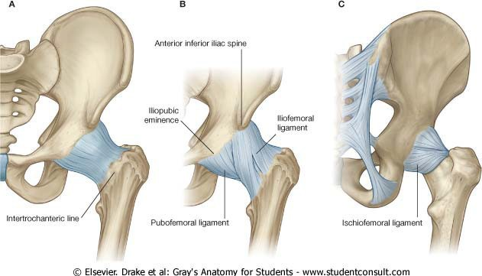

FIGURE 2
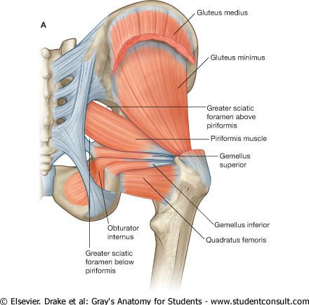

Figure 3: Muscle Groups acting on the Hip

Anterior Compartment Medial Compartment Posterior- Gluteal Region
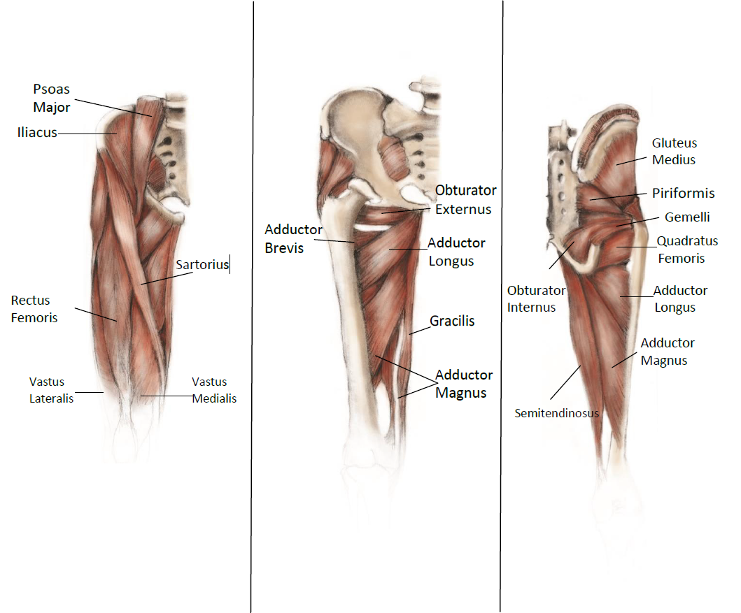

Module 2 Reference List

1. Black, D. M., & Thompson, D. E. (1999). The effect of alendronate therapy on osteoporotic fracture in the vertebral fracture arm of the Fracture Intervention Trial. Int J Clin Pract Suppl, 101, 46-50.

2. Burstein, A. H., Reilly, D. T., & Martens, M. (1976). Aging of bone tissue: mechanical properties. J Bone Joint Surg Am, 58(1), 82-86.

3. Cooper, C., Atkinson, E.J., O’Fallon, W.M., Melton, L.J. III. (1992). Incidence of clinically diagnosed vertebral fractures: A population-based study in Rochester, Minnesota, 1985-1989. J Bone miner Res, 7(2):221-227.

4. Courtney, A. C., Wachtel, E. F., Myers, E. R., & Hayes, W. C. (1995). Age-related reductions in the strength of the femur tested in a fall-loading configuration. J Bone Joint Surg Am, 77(3), 387-395.

5. Ebbesen, E. N., Thomsen, J. S., Beck-Nielsen, H., Nepper-Rasmussen, H. J., & Mosekilde, L. (1999). Age- and gender-related differences in vertebral bone mass, density, and strength. J Bone Miner Res, 14(8), 1394-1403.
6. Fick, A. (1856). Medizinische Physik. Supplementband in Müller-Pouillet's Lehrbuch der Physik für Mediziner

7. Goh, S., Price, R. I., Leedman, P. J., & Singer, K. P. (1999). The relative influence of vertebral body and intervertebral disc shape on thoracic kyphosis. Clin Biomech (Bristol, Avon), 14(7), 439-448.

8. Goldstein, S. A., Goulet, R., & McCubbrey, D. (1993). Measurement and significance of three- dimensional architecture to the mechanical integrity of trabecular bone. Calcif Tissue Int, 53 Suppl 1, S127-132; discussion 132-123.

9. Goulet, R. W., Goldstein, S. A., Ciarelli, M. J., Kuhn, J. L., Brown, M. B., & Feldkamp, L. A. (1994). The relationship between the structural and orthogonal compressive properties of trabecular bone. J Biomech, 27(4), 375-389.

10. Greenspan, S. L., Myers, E. R., Maitland, L. A., Resnick, N. M., & Hayes, W. C. (1994). Fall severity and bone mineral density as risk factors for hip fracture in ambulatory elderly. JAMA, 271(2), 128-133.

11. Grisso, J. A., & Ness, R. B. (1996). Update in women's health. Ann Intern Med, 125(3), 213-220.

12. Gunnes, M., Mellstrom, D., & Johnell, O. (1998). How well can a previous fracture indicate a new fracture? A questionnaire study of 29,802 postmenopausal women. Acta Orthop Scand, 69(5), 508-512.

13. Hayes, W. C., Myers, E. R., Morris, J. N., Gerhart, T. N., Yett, H. S., & Lipsitz, L. A. (1993). Impact near the hip dominates fracture risk in elderly nursing home residents who fall. Calcif Tissue Int, 52(3), 192-198.

14. Keyak, J. H., Rossi, S. A., Jones, K. A., Les, C. M., & Skinner, H. B. (2001). Prediction of fracture location in the proximal femur using finite element models. Med Eng Phys, 23(9), 657-664.

15. Lauritzen, J. B., & Lund, B. (1993). Risk of hip fracture after osteoporosis fractures. 451 women with fracture of lumbar spine, olecranon, knee or ankle. Acta Orthop Scand, 64(3), 297-300.

16. Leeuwenhoek, A. (1674). Microscopical observations concerning blood, milk, bone, the brain, spittle, and cuticula, etc. Phil Trans, 9, 121-128.

17. McCalden, R. W., McGeough, J. A., Barker, M. B., & Court-Brown, C. M. (1993). Age- related changes in the tensile properties of cortical bone. The relative importance of changes in porosity, mineralization, and microstructure. J Bone Joint Surg Am, 75(8), 1193-1205.

18. McCalden, R. W., McGeough, J. A., & Court-Brown, C. M. (1997). Age-related changes in the compressive strength of cancellous bone. The relative importance of changes in density and trabecular architecture. J Bone Joint Surg Am, 79(3), 421-427.

19. Melton, L. J., 3rd, Atkinson, E. J., Khosla, S., O'Fallon, W. M., & Riggs, B. L. (1999). Secondary osteoporosis and the risk of vertebral deformities in women. Bone, 24(1), 49-55.
20. Monro, A. (1776). Anatomy of the humane bones. (10 ed.). Dublin.

21. Mosekilde, L., & Danielsen, C. C. (1987). Biomechanical competence of vertebral trabecular bone in relation to ash density and age in normal individuals. Bone, 8(2), 79-85.

22. Nachemson, A. L. (1981). Disc pressure measurements. Spine (Phila Pa 1976), 6(1), 93-97.

23. Nordin, M. & Frankel, VH. (2001) Basic Biomechanics of the Musculoskeletal System (3rd Ed.,).Lippincott, Williams & Wilkins.

24. Roux, W. (1883). Beiträge zur Morphologie der funktionellen Anpassung. Archiv für Anatomie und Entwickelungsgeschichte., 76–162.

25. Silva, M. J., & Touhey, D. C. (2007). Bone formation after damaging in vivo fatigue loading results in recovery of whole-bone monotonic strength and increased fatigue life. J Orthop Res, 25(2), 252- 261.

26. von Meyer, H. (1867). Die Architecktur der Spongiosa. Reichert und Dubois-Reymond’s Archiv, 34: 615-28.

27. Wolff, J. (1870). Ueber die innere Architektur der Knochen und ihre Bedeutung für die Frage vom Knochenwachstum. . Arch. Pathol. Anat. Physiol. Klin. Med. Virchows Arch., 50, 389-453.

28. Zioupos, P., & Currey, J. D. (1998). Changes in the stiffness, strength, and toughness of human cortical bone with age. Bone, 22(1), 57-66.

